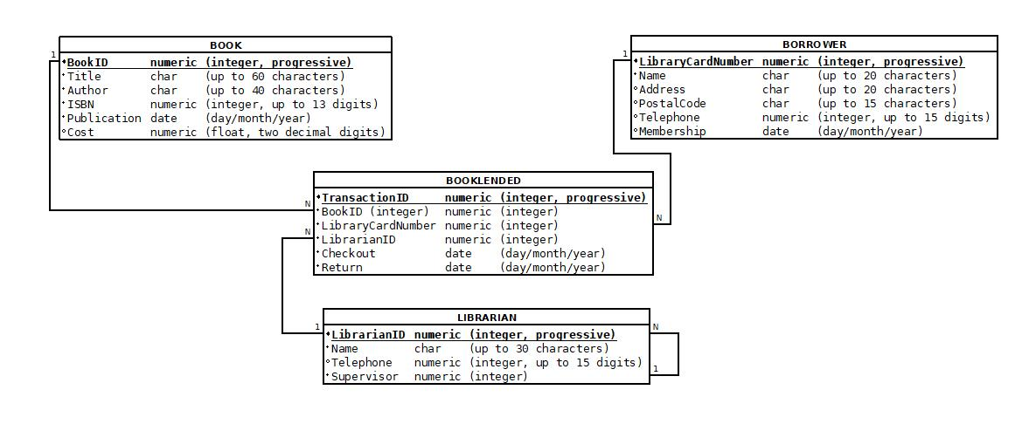

***Book Relation***

***Attribute Data Constraints***

***BookID Numeric (integer, progressive) PRIMARY KEY.***

*Title Text (up to 60 characters) NOT NULL.*

*Author Text (up to 40 characters) NOT NULL.*

*ISBN Text (up to 13 characters) NOT NULL, UNIQUE.*

*Publication Date (day – month - year). NOT NULL.*

*Cost Numeric (float, two decimal digits).*

***Borrower Relation***

***Attribute Data Constraints***

***CardNumber Numeric (integer, progressive) PRIMARY KEY.***

*Name Text (up to 20 characters) NOT NULL.*

*Address Text (up to 20 characters)*

*Postal Code Text (up to 15 characters).*

*Telephone Numeric (integer, up to 15 digits) UNIQUE.*

*Membership Date (date – month - year).*

***Librarian Relation***

***Attribute Data Constraints***

***LibrarianID* *Numeric (integer, progressive) PRIMARY KEY****.*

*Name Text (up to 30 characters) NOT NULL.*

*Telephone Numeric (integer up to 15 digits).*

*Supervisor Numeric (integer) FOREIGN KEY.*

***BookLended Relation***

***Attribute Data Constraints***

***TransactionID Numeric (integer, progressive) PRIMARY KEY.***

*BookID Numeric (integer) FOREIGN KEY.*

*CardNumber Numeric (integer) FOREIGN KEY.*

*LibrarianID Numeric (integer) FOREIGN KEY.*

*Checkout Date (date – month - year) NOT NULL.*

*Return Date (date – month - year) NOT NULL.*